**EXPERIMENT-8**

**DATA LINK LAYER TRAFFIC SIMULATION USING PACKET TRACER ANALYSIS OF ARP**

**Aim**: To implement Data Link Layer Traffic Simulation using Packet Tracer Analysis of ARP.

**Software / Apparatus required:** Packet Tracer / End devices, Switches, connectors.

**Requirements:**

1. End device - They are the devices through which we can pass message from one device to another and they are interconnected.

2 Switch/Hub - Interface Between two devices.

3. Cable - Used to connect two devices **Procedure:**

1. Open packet tracer.
2. Click on the list the available capture interface.
3. Choose the PCS, server and Hub.
4. Later give connection from hub to the remaining pcs.
5. Give IP address to the pcs with configuration.
6. Simulate the source and destination.

**Output:**

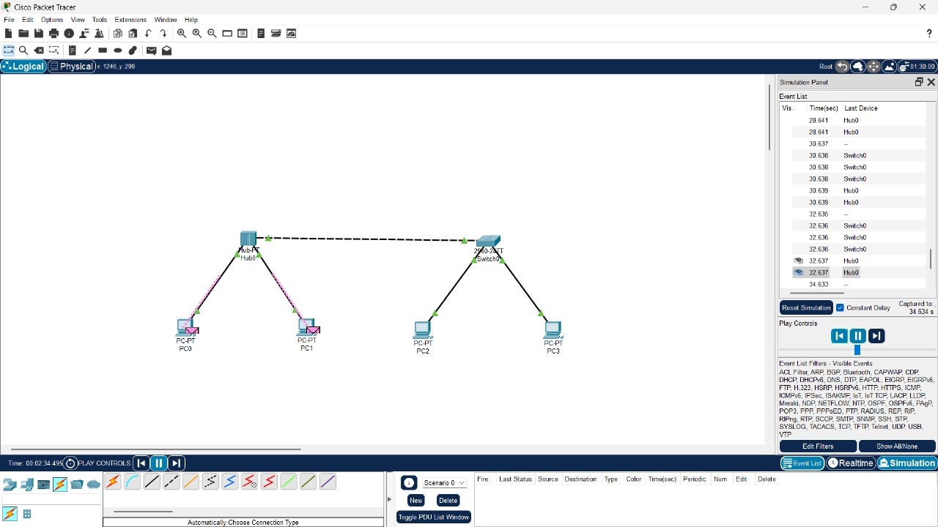

**Result:** Thus theData Link Layer Traffic Simulation using Packet Tracer Analysis of ARP is implemented.